AIAC LAB 16.1
2303A51015(SRIKARAN) BATCH-01
Task 1 – Student Information System Schema
Task:
Design a database schema for a Student Information System and
generate queries using AI.
Instructions:
• Tables: Students, Courses, Enrollments.
• Define primary keys, foreign keys, and relationships.
• Generate queries:
o Insert a new student record.
o Fetch all courses enrolled by a student.
o Count number of students in each course.
Expected Output:
• SQL CREATE TABLE statements and queries for student–
course relationships
ANSWER
-- Students Table
CREATE TABLE Students (
student_id SERIAL PRIMARY KEY,
name VARCHAR(100),
email VARCHAR(100) UNIQUE,
age INT
);

-- Courses Table
CREATE TABLE Courses (
course_id SERIAL PRIMARY KEY,
course_name VARCHAR(100),
credits INT
);

-- Enrollments Table (Bridge Table)
CREATE TABLE Enrollments (
enrollment_id SERIAL PRIMARY KEY,
student_id INT,
course_id INT,

FOREIGN KEY (student_id) REFERENCES Students(student_id),
FOREIGN KEY (course_id) REFERENCES Courses(course_id)
);
--insert a new student
INSERT INTO Students (name, email, age)
VALUES ('John Doe', 'john.doe@example.com', 20);
INSERT INTO Students (name, email, age)
VALUES ('Jane Smith', 'jane.smith@example.com', 22);
--fetch all courses of a student
SELECT c.course_name
FROM Courses c
JOIN Enrollments e ON c.course_id = e.course_id
JOIN Students s ON e.student_id = s.student_id

WHERE e.student_id = 1; -- Replace with the desired student_id
-- count students in each course
SELECT c.course_name, COUNT(e.student_id) AS student_count
FROM Courses c
LEFT JOIN Enrollments e ON c.course_id = e.course_id
GROUP BY c.course_name;
-- insert course
INSERT INTO Courses (course_name, credits)
VALUES ('Database Systems', 3),
('Math',4),
('Computer science',5);
--enroll students
INSERT INTO Enrollments (student_id, course_id)
VALUES (1, 1),
(1, 2),
(2, 1),
(2, 3);
-- Show all students
SELECT * FROM Students;

-- Show all courses
SELECT * FROM Courses;

-- Show all enrollments
SELECT * FROM Enrollments;
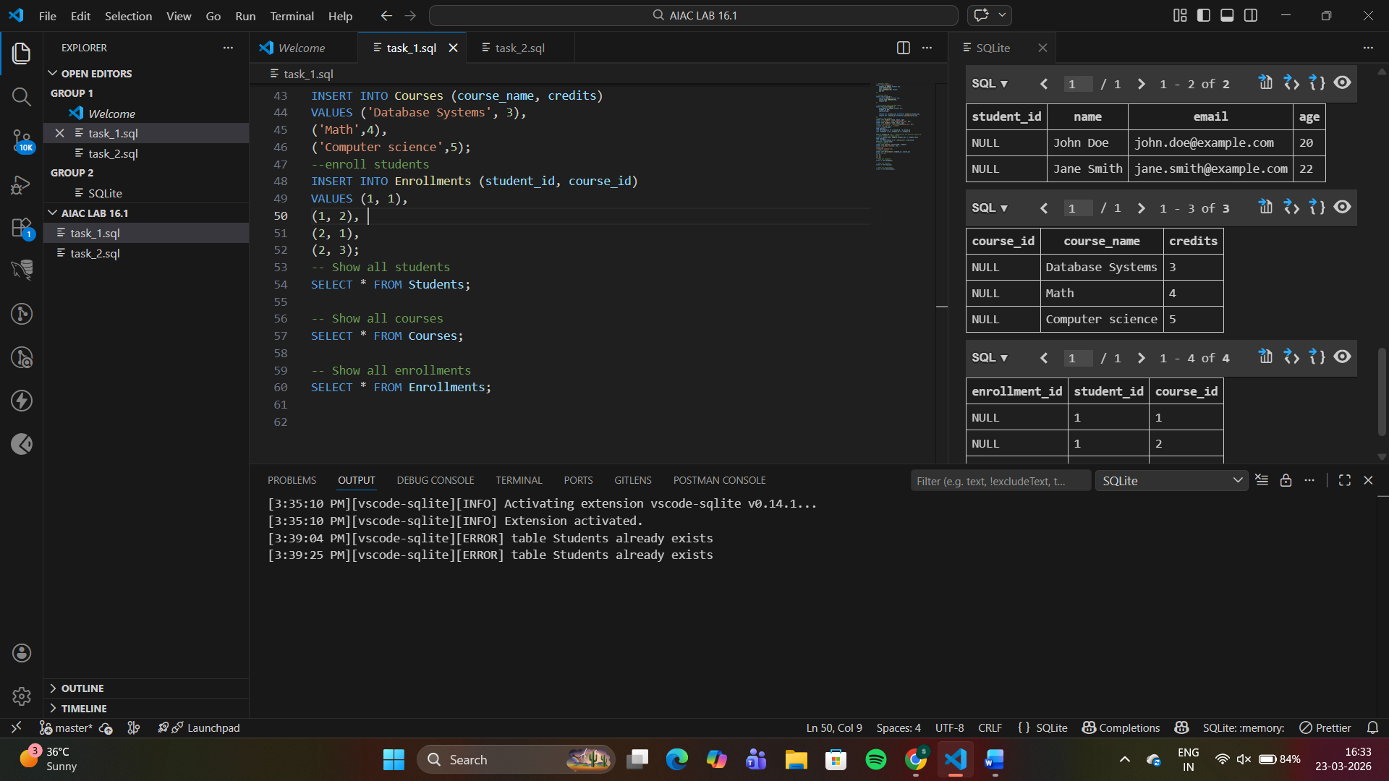
Task 2 – Hospital Management Database
Task:
Create schema and queries for a Hospital Management System.
Instructions:
• Tables: Doctors, Patients, Appointments.
• Use AI to define constraints (unique IDs, valid dates).
• Generate queries:
o List all appointments for a specific doctor.
o Retrieve patient history by patient ID.
o Count total patients treated by each doctor.
Expected Output:
• Normalized schema and SQL queries with joins.
ANSWER
-- Remove old tables (avoid errors)
DROP TABLE IF EXISTS Appointments;
DROP TABLE IF EXISTS Patients;
DROP TABLE IF EXISTS Doctors;

-- Doctors Table
CREATE TABLE Doctors (
doctor_id INTEGER PRIMARY KEY AUTOINCREMENT,
name TEXT NOT NULL,
specialty TEXT NOT NULL
);

-- Patients Table
CREATE TABLE Patients (
patient_id INTEGER PRIMARY KEY AUTOINCREMENT,
name TEXT NOT NULL,
age INTEGER CHECK(age > 0)
);

-- Appointments Table
CREATE TABLE Appointments (
appointment_id INTEGER PRIMARY KEY AUTOINCREMENT,
doctor_id INTEGER NOT NULL,
patient_id INTEGER NOT NULL,
appointment_date TEXT NOT NULL,

FOREIGN KEY (doctor_id) REFERENCES Doctors(doctor_id),
FOREIGN KEY (patient_id) REFERENCES Patients(patient_id)
);
-- Insert Doctors
INSERT INTO Doctors (name, specialty) VALUES
('Dr. Smith', 'Cardiology'),
('Dr. Johnson', 'Neurology'),
('Dr. Lee', 'Pediatrics');

-- Insert Patients
INSERT INTO Patients (name, age) VALUES
('John Doe', 45),
('Jane Smith', 38),
('Bob Johnson', 52);

-- Insert Appointments
INSERT INTO Appointments (doctor_id, patient_id, appointment_date) VALUES
(1, 1, '2024-07-01'),
(1, 2, '2024-07-02'),
(2, 3, '2024-07-03');
SELECT d.name AS doctor_name, p.name AS patient_name, a.appointment_date
FROM Appointments a
JOIN Doctors d ON a.doctor_id = d.doctor_id
JOIN Patients p ON a.patient_id = p.patient_id
WHERE d.doctor_id = 1;
SELECT p.name AS patient_name, d.name AS doctor_name, a.appointment_date
FROM Appointments a
JOIN Patients p ON a.patient_id = p.patient_id
JOIN Doctors d ON a.doctor_id = d.doctor_id
WHERE p.patient_id = 1;
SELECT d.name AS doctor_name, COUNT(a.patient_id) AS total_patients
FROM Doctors d
LEFT JOIN Appointments a ON d.doctor_id = a.doctor_id
GROUP BY d.name;
SELECT * FROM Doctors;
SELECT * FROM Patients;
SELECT * FROM Appointments;

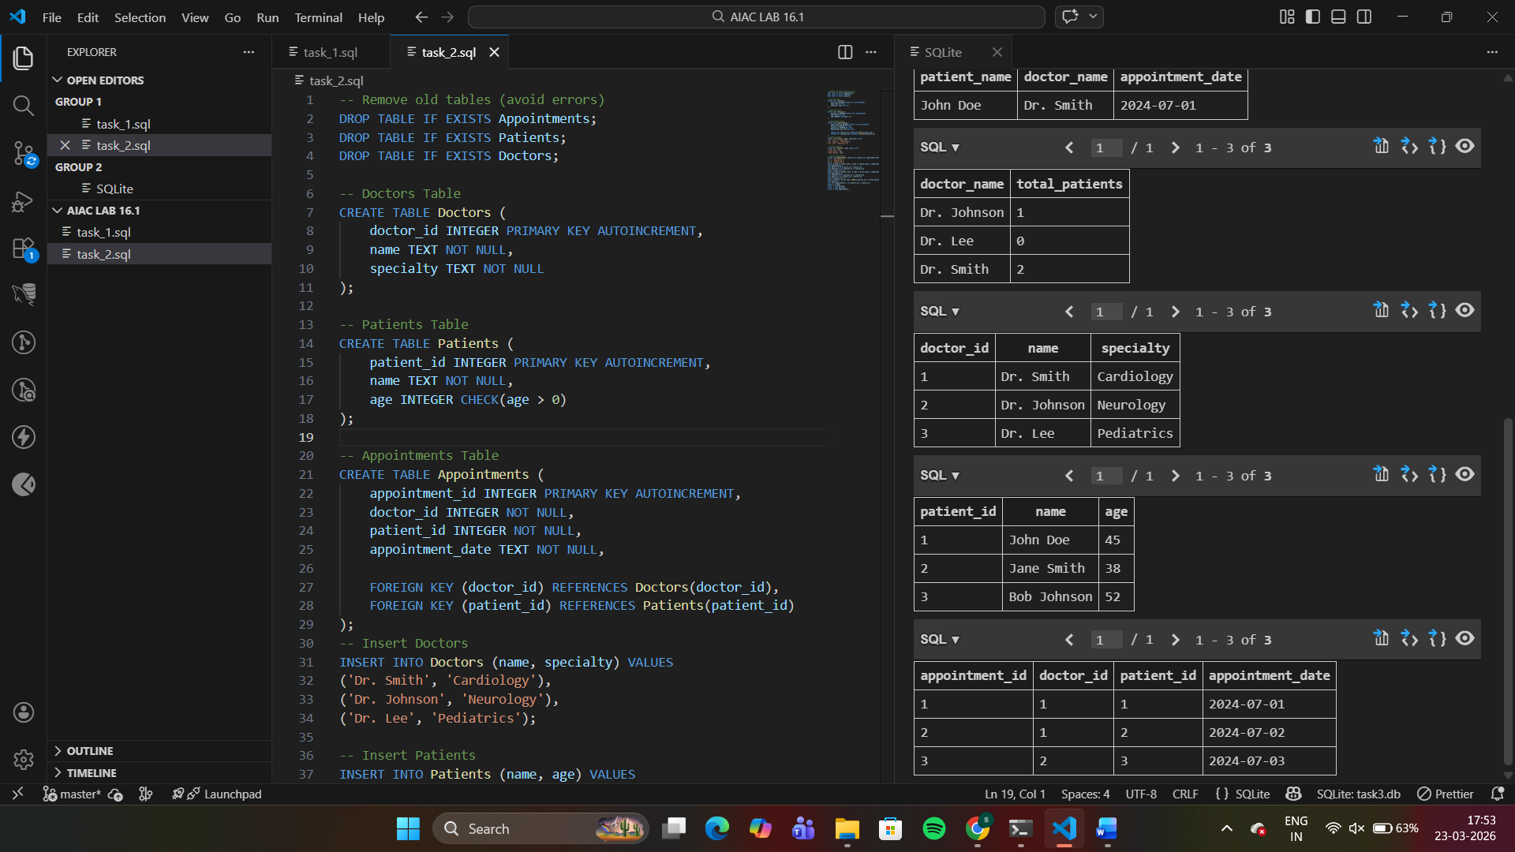
Task 3 – Library Database
Task:
Design schema for a Library Management System.
Instructions:
• Tables: Books, Members, Loans.
• Use AI to suggest indexing strategy for faster queries.
• Generate queries:
o Retrieve all books currently issued.
o Find overdue books (loan date > 30 days).
o Count number of books loaned by each member.
Expected Output:
• Schema + SQL queries demonstrating joins and conditions.
ANSWER
-- =========================
-- RESET (IMPORTANT)
-- =========================
DROP TABLE IF EXISTS Loans;
DROP TABLE IF EXISTS Books;
DROP TABLE IF EXISTS Members;

-- =========================
-- CREATE TABLES
-- =========================
CREATE TABLE Books (
book_id INTEGER PRIMARY KEY AUTOINCREMENT,
title TEXT,
author TEXT,
available BOOLEAN
);

CREATE TABLE Members (
member_id INTEGER PRIMARY KEY AUTOINCREMENT,
name TEXT,
email TEXT UNIQUE
);

CREATE TABLE Loans (
loan_id INTEGER PRIMARY KEY AUTOINCREMENT,
book_id INTEGER,
member_id INTEGER,
loan_date DATE,
return_date DATE,
FOREIGN KEY (book_id) REFERENCES Books(book_id),
FOREIGN KEY (member_id) REFERENCES Members(member_id)
);

-- =========================
-- INSERT DATA
-- =========================
INSERT INTO Books (title, author, available) VALUES
('Java Basics', 'James Gosling', 0),
('Python Guide', 'Guido Rossum', 0),
('SQL Mastery', 'Oracle Team', 1);

INSERT INTO Members (name, email) VALUES
('Charan', 'charan@gmail.com'),
('Ravi', 'ravi@gmail.com');

-- ✅ CORRECT DATE FORMAT (SQLite)
INSERT INTO Loans (book_id, member_id, loan_date, return_date) VALUES
(1, 1, DATE('now', '-10 days'), NULL),
(2, 2, DATE('now', '-40 days'), NULL);

-- =========================
-- QUERIES
-- =========================

-- 1. Currently issued books
SELECT b.title, m.name, l.loan_date
FROM Loans l
JOIN Books b ON l.book_id = b.book_id
JOIN Members m ON l.member_id = m.member_id
WHERE l.return_date IS NULL;

-- 2. Overdue books (>30 days)
SELECT b.title, m.name, l.loan_date
FROM Loans l
JOIN Books b ON l.book_id = b.book_id
JOIN Members m ON l.member_id = m.member_id
WHERE l.return_date IS NULL
AND l.loan_date < DATE('now', '-30 days');

-- 3. Count books per member
SELECT m.name, COUNT(l.loan_id) AS total_books
FROM Members m
LEFT JOIN Loans l ON m.member_id = l.member_id
GROUP BY m.name;

-- =========================
-- FINAL PRINT TABLES
-- =========================
SELECT * FROM Books;
SELECT * FROM Members;
SELECT * FROM Loans;

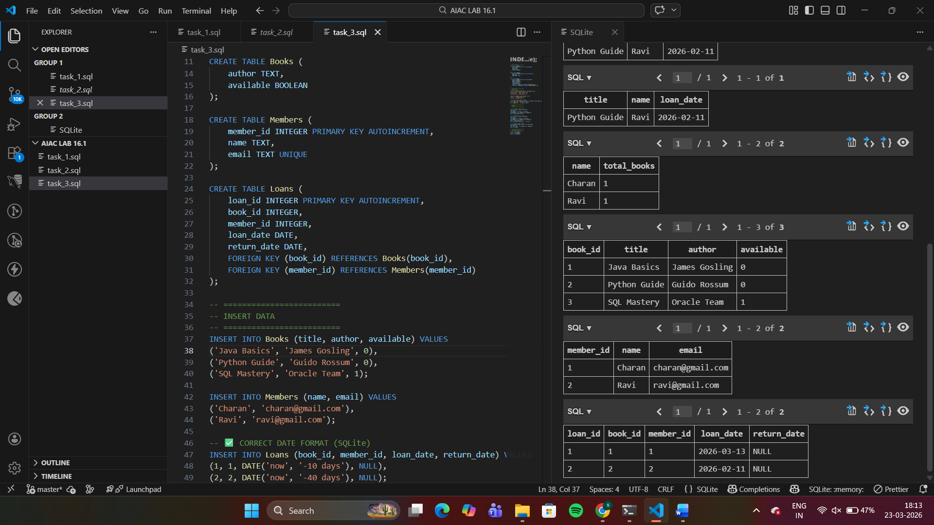
Task 4 – Real-Time Application: Online Shopping Database
Scenario:
Design a database for an E-commerce platform.
Requirements:
• Tables: Users, Products, Orders, OrderDetails.
• Generate queries to:
o Retrieve all orders by a user.
o Find the most purchased product.
o Calculate total revenue in a given month.
• AI should also suggest normalization improvements and
query optimization.
Expected Output:
• Complete schema with relationships + SQL queries for
Analytics
ANSWER
SELECT 'USERS TABLE';
SELECT * FROM Users;

SELECT 'PRODUCTS TABLE';
SELECT * FROM Products;

SELECT 'ORDERS TABLE';
SELECT * FROM Orders;

SELECT 'ORDER DETAILS TABLE';
SELECT * FROM OrderDetails;
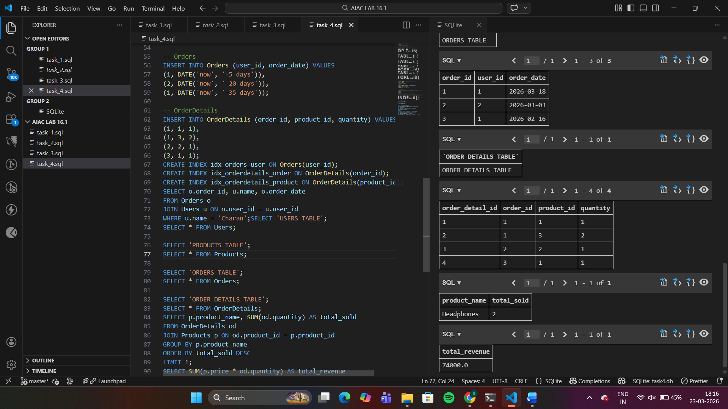
Task 5 – University Examination Database
Design a database schema for a University Examination System and
generate SQL queries using AI.
Instructions:
• Tables: Students, Subjects, Exams, Results.
• Define primary keys, foreign keys, and referential integrity
constraints.
• Generate queries:
o Insert examination results for a student.
o Retrieve subject-wise marks for a student.
o Calculate average marks for each subject.
Expected Output:
• Normalized schema and SQL queries involving aggregation and
Joins
ANSWER
-- =========================
-- RESET
-- =========================
DROP TABLE IF EXISTS Results;
DROP TABLE IF EXISTS Exams;
DROP TABLE IF EXISTS Subjects;
DROP TABLE IF EXISTS Students;

-- =========================
-- TABLES
-- =========================

-- Students
CREATE TABLE Students (
student_id INTEGER PRIMARY KEY AUTOINCREMENT,
name TEXT,
email TEXT UNIQUE
);

-- Subjects
CREATE TABLE Subjects (
subject_id INTEGER PRIMARY KEY AUTOINCREMENT,
subject_name TEXT
);

-- Exams
CREATE TABLE Exams (
exam_id INTEGER PRIMARY KEY AUTOINCREMENT,
subject_id INTEGER,
exam_date DATE,
FOREIGN KEY (subject_id) REFERENCES Subjects(subject_id)
);

-- Results
CREATE TABLE Results (
result_id INTEGER PRIMARY KEY AUTOINCREMENT,
student_id INTEGER,
exam_id INTEGER,
marks INTEGER,
FOREIGN KEY (student_id) REFERENCES Students(student_id),
FOREIGN KEY (exam_id) REFERENCES Exams(exam_id)
);
-- Students
INSERT INTO Students (name, email) VALUES
('Charan', 'charan@gmail.com'),
('Ravi', 'ravi@gmail.com');

-- Subjects
INSERT INTO Subjects (subject_name) VALUES
('Maths'),
('Science'),
('English');

-- Exams
INSERT INTO Exams (subject_id, exam_date) VALUES
(1, DATE('now', '-10 days')),
(2, DATE('now', '-5 days')),
(3, DATE('now', '-2 days'));

-- Results
INSERT INTO Results (student_id, exam_id, marks) VALUES
(1, 1, 85),
(1, 2, 78),
(2, 1, 65),
(2, 3, 90);
CREATE INDEX idx_results_student ON Results(student_id);
CREATE INDEX idx_results_exam ON Results(exam_id);
CREATE INDEX idx_exams_subject ON Exams(subject_id);
INSERT INTO Results (student_id, exam_id, marks)
VALUES (1, 3, 88);
SELECT s.name, sub.subject_name, r.marks
FROM Results r
JOIN Students s ON r.student_id = s.student_id
JOIN Exams e ON r.exam_id = e.exam_id
JOIN Subjects sub ON e.subject_id = sub.subject_id
WHERE s.name = 'Charan';
SELECT sub.subject_name, AVG(r.marks) AS avg_marks
FROM Results r
JOIN Exams e ON r.exam_id = e.exam_id
JOIN Subjects sub ON e.subject_id = sub.subject_id
GROUP BY sub.subject_name;
SELECT 'STUDENTS TABLE';
SELECT * FROM Students;

SELECT 'SUBJECTS TABLE';
SELECT * FROM Subjects;

SELECT 'EXAMS TABLE';
SELECT * FROM Exams;

SELECT 'RESULTS TABLE';
SELECT * FROM Results;

